FLUTTER INTRODUCTION

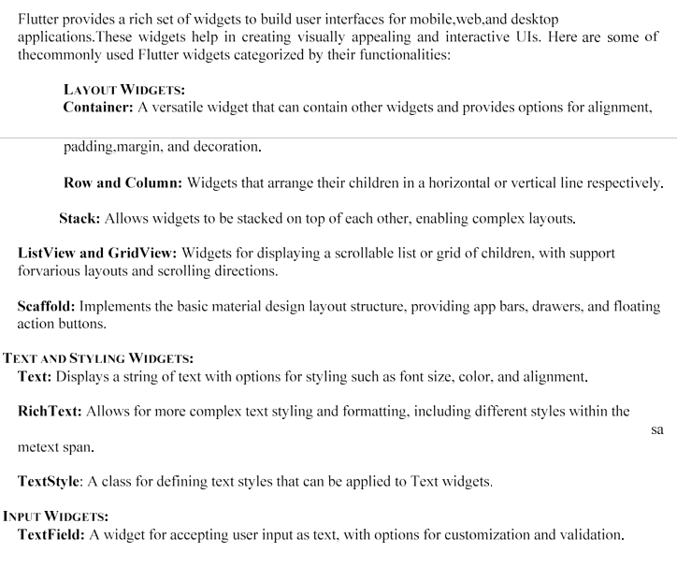

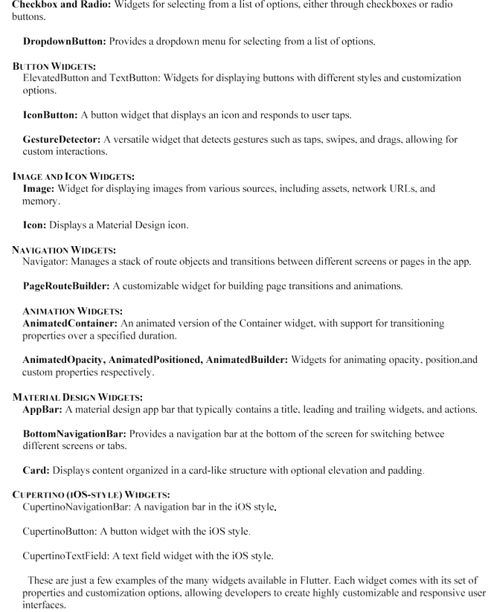

TASK2

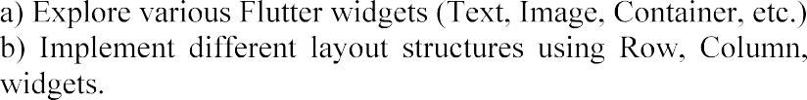
TASK2A:
import 'package:flutter/material.dart';
void main() {
runApp(const MyApp());
}
class MyApp extends StatelessWidget {
const MyApp({super.key});
@override
Widget build(BuildContext context) {
return MaterialApp(
debugShowCheckedModeBanner: false,
home: Scaffold(
appBar: AppBar(
title: const Text("Flutter Widgets"),
),
body: Center(
child: Column(
mainAxisAlignment: MainAxisAlignment.center,
children: [
const Text(
"Welcome to Flutter",
style: TextStyle(
fontSize: 28,
fontWeight: FontWeight.bold,
color: Colors.blue,
),
),
const SizedBox(height: 20),
Image.network(
"https://picsum.photos/200",
height: 150,
),
const SizedBox(height: 20),
Container(
width: 200,
height: 80,
decoration: BoxDecoration(
color: Colors.orange,
borderRadius: BorderRadius.circular(10),
),
child: const Center(
child: Text(
"Container Widget",
style: TextStyle(
color: Colors.white,
fontSize: 20,
),
),
),
),
const SizedBox(height: 20),
const Icon(
Icons.favorite,
size: 50,
color: Colors.red,
),
const SizedBox(height: 20),
ElevatedButton(
onPressed: () {},
child: const Text("Click Me"),
),
],
),
),
),
);
}
}
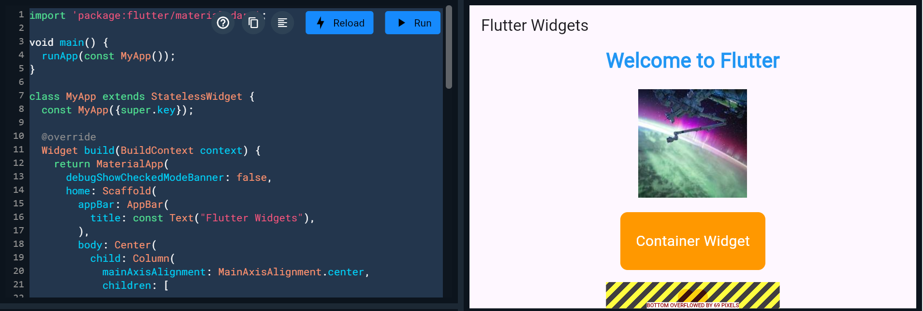

TASK2B:
